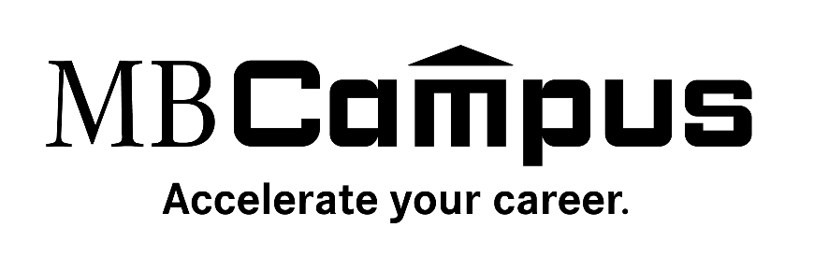
Are you looking for a career with one of the world’s top luxury brands? Do you want to learn and grow with the best?
Now you have an opportunity to join Mercedes-Benz in its pursuit of next-level vehicle technology, service, and repair. Working on a vehicle as sophisticated as a Mercedes-Benz requires a thorough understanding of cutting-edge technology. From engine diagnostics to electrical systems, these courses combine online and real-world teachings to prepare you with the skills you’ll need to become a successful Mercedes-Benz technician.
[INSERT COLLEGE NAME] MB Campus program opens your pathway to become a Registered Technician with an authorized Mercedes-Benz dealership partner.

MB Campus Program Highlights:
- Exposure to leading edge Mercedes-Benz products and technologies
- Develop the skills needed to start a career as a successful Mercedes-Benz Registered Technician and beyond*
- Access to 40+ certified Mercedes-Benz eLearning courses (Engines, Information Systems, etc.)
- Gain hands-on experience with the latest equipment in the industry
- Receive basic to intermediate Mercedes-Benz electrical systems training from campus instructors
- Opportunity to receive official Mercedes-Benz branded accessories from your partnering dealership(s)
- 1-2 year program with no additional class registration required**

How to Get Involved:
- Speak with your automotive instructor about how MB Campus is incorporated into the curriculum at your school
- If interested, ask your instructor how to create an account via the program’s online platform (Logic Bay – mbstar.logicbay.com)
- Start on the express path laid out by your instructors and begin taking eLearnings
- Communicate with your instructor(s) about possible opportunities at your partnering Mercedes-Benz dealership(s)
- Please have your instructor(s) reach out to techcareers@mbusa.com with any questions. Thank you!

